Algebra 2
Graphing Absolute Value Functions

- $f\left(x\right)=\left|x\right|$ 2. $f\left(x\right)=\left|x-2\right|$

3. $f\left(x\right)=\left|x\right|+4$ 4. $f\left(x\right)=\left|x-3\right|+2$

5. $f\left(x\right)=\left|x+3\right|-1$ 6. $f\left(x\right)=\left|x-1\right|-3$

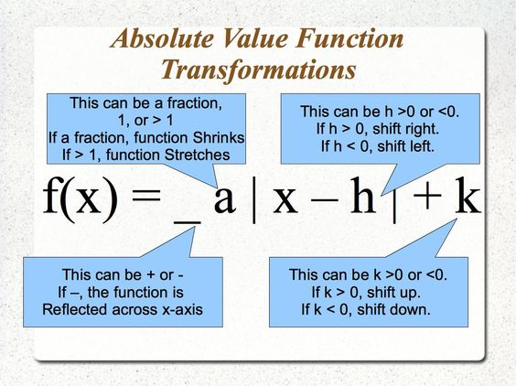

$$f\left(x\right)=\left|x-6\right|+1$$  Vertex (_____ , ______)  Opens: Up / Down  Shrink/ Stretch/ Same | $$f\left(x\right)=-\left|x-4\right|$$  Vertex (_____ , ______)  Opens: Up / Down  Shrink/ Stretch/ Same | $$f\left(x\right)=\frac{1}{2}\left|x-2\right|+4$$  Vertex (_____ , ______)  Opens: Up / Down  Shrink/ Stretch/ Same
$$f\left(x\right)=-2\left|x+7\right|+11$$  Vertex (_____ , ______)  Opens: Up / Down  Shrink/ Stretch/ Same | $$f\left(x\right)=\frac{5}{2}\left|x-1\right|-9$$  Vertex (_____ , ______)  Opens: Up / Down  Shrink/ Stretch/ Same | $$f\left(x\right)=-\left|x\right|-1$$  Vertex (_____ , ______)  Opens: Up / Down  Shrink/ Stretch/ Same
$$f\left(x\right)=-3\left|x\right|-2$$  Vertex (_____ , ______)  Opens: Up / Down  Shrink/ Stretch/ Same | $$f\left(x\right)=\frac{4}{9}\left|x+2\right|+14$$  Vertex (_____ , ______)  Opens: Up / Down  Shrink/ Stretch/ Same | $$f\left(x\right)=\left|x-6\right|+5$$  Vertex (_____ , ______)  Opens: Up / Down  Shrink/ Stretch/ Same
$$f\left(x\right)=.75\left|x+8\right|$$  Vertex (_____ , ______)  Opens: Up / Down  Shrink/ Stretch/ Same | $$f\left(x\right)=-9\left|x\right|-3$$  Vertex (_____ , ______)  Opens: Up / Down  Shrink/ Stretch/ Same | $$f\left(x\right)=-14\left|x-10\right|-9$$  Vertex (_____ , ______)  Opens: Up / Down  Shrink/ Stretch/ Same

