Algebra 2 – Chapter 2 Review

1. Find the domain of the relation {(2, 2), (1, 4), (4, 0)}. Then determine whether the relation is a function.

2. Find f(1) if f(x) = 4x – 1.

3. Write three different examples of a linear function?

4. Write $y=8x-1$ in standard form.

5. What is the slope of a line that passes through (2,3) and the point (5, 8)?

6. What is the slope of a line that is parallel to y = 4x + 1?

7. What is the slope of the line with equation 3x + 6y = 36?

8. What is the slope of the line $y=4x-4$?

9. What is the x-intercept of the line 4x+7y=28

10. What is the transformation of the graph $f\left(x\right)=\left|x-1\right|+5$?

11. Identify the graph of y=2.

12. Identify the vertex of y = $3\left|x\right|+5.$

13. What is the slope of the inequality y>6x-5?

14. The graph of the linear inequality y < 7x – 5 is the shaded region _________ the graph.

15. What is the vertex of the graph $f\left(x\right)=5\left|x-2\right|+5$?

On problems 16 and 17, use the pictures to answer each question.

16. 17.

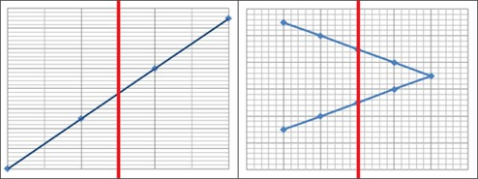

Is the graph above a function? Is the graph above a function?

Graph each equation or inequality accurately.

18. y = $\left|x-2\right|$ 19. y < -2x-1 20. 15x + 3y = 12

21. Write an equation in slope intercept form parallel to the line through y = 2x-1, but going through the point (0, -1).

22. Write an equation in point-slope form of a line that contains the points (1, 3) and (4, 0)

23. Write an equation in slope-intercept form of slope of 5 and contains the point (-2, 1). (Hint write in point-slope FIRST)

24. Find the slope of a line that contains the points (0, 3) and (1, 5)

25. Write an equation in point slope-form of a line perpendicular to the line with equation $y=\frac{1}{4}x+5$ and contains the point (2, 4).

