Point-Slope Form of a Line
Find the Point-Slope equation for the line containing the given point and having the given slope.
1. (4, -3), m = -1 2. (-5, -6), m = 2

3. (-7, 2), m = 3 4. (3,5), m = -2

5. (6, -2), m = -3 6. (5, -2), m = 2

7. (7,0), m = 4 8. (0, 9), m = -2

9. (5, -1), m = $\frac{1}{5}$ 10. (-3, -2), m = $\frac{1}{4}$

Give the Point-Slope form of the equation that passes through the given points.
11. (0, 8) and (-1, 10) 12. (-6, 8) and (4, 8)

13. (4, 5) and (-3, 8) 14. (0, 9) and (2, 0)

15. (-1, 7), (8, -2) 16. (4, 0), (0, 5)

17. (5, 7), (-1, 3) 18. (0, 0), (-4, 3)

19. (-3, -5), (3, -15) 20. $(-\frac{1}{2}, \frac{1}{2}),$ $(\frac{1}{4}, \frac{3}{4})$

Graph the following lines by first giving the point and the slope.
21. $y+2=\frac{1}{3}(x+1)$ 22. $y-3=-2(x-4)$
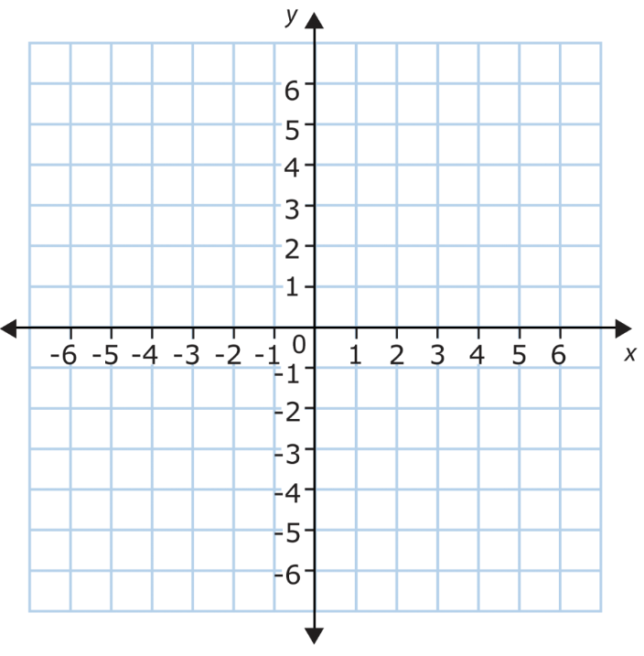
Point _________ Slope _________ Point _________ Slope _________

23. $y-5=3x$ 24. $y+3=0(x-3)$
Point _________ Slope _________ Point _________ Slope _________

