Name: __________________________
Write Equations of Parallel and Perpendicular Lines
Write an equation of the line that passes through the given point and is parallel to the given line.
1. (4, 7), y = 5x –3 2. (3, –2), y = x + 1 3. (–9, 11), 5x –10y = 3

4. (2, 6), y = $\frac{\text{3}}{\text{7}}$x + 4 5. (7, 1), y = 2x – 2 6. (-5, -2), 8x + 2y = 16

Write an equation of the line that passes through the given point and is perpendicular to the given line.
7. (4, 7), y = 5x –3 8. (3, –2), y = x + 1 9. (–9, 11), 5x –10y = 3

10. (2, 6), y = $\frac{\text{3}}{\text{7}}$x + 4 11. (7, 1), y = 2x – 2 12. (-5, -2), 8x + 2y = 16

Graph the given lines.
13. y = $\frac{\text{3}}{\text{4}}$x + 2 and a perpendicular line passing through the point (4, 7)
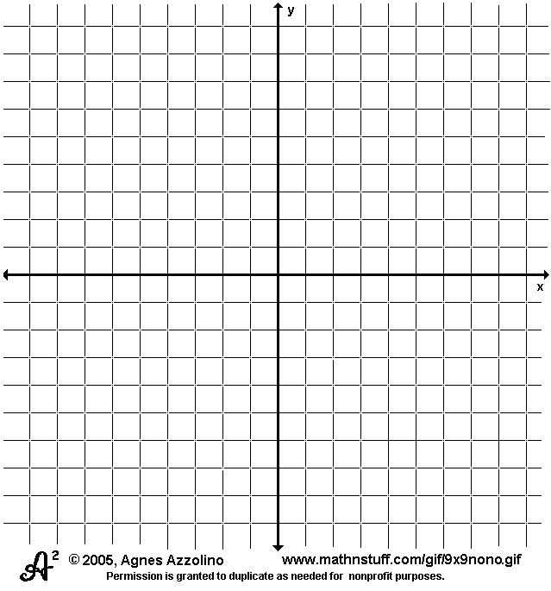
14. y = -5x -1 and a parallel line passing through the point (2, 1)

15. 3x + 4y = -9 and a perpendicular line passing through the point (5, 2)

